Childcare Offer for Wales and Farmers
If you are a farmer living in Wales who has a child who is yet to turn three, now is the time to ensure you are ready with the right evidence to apply for the Childcare Offer once your child turns three.

What is the Childcare Offer for Wales?
The Childcare Offer for Wales provides up to 30 hours of government-funded early education and childcare to eligible working parents of three and four year olds for 48 weeks of the year. This builds on the existing universal commitment to early education, which provides all three and four year olds with a minimum of 10 hours per week of provision known as Foundation Phase Nursery (FPN).
Under the Childcare Offer, during school term time working parents are entitled to a maximum of 20 hours of funded childcare, in addition to the minimum 10 hours FPN each week, making up a total of 30 hours of funded provision. The exact number of hours provided under FPN varies by local authority, with many providing more than 10 hours per week.
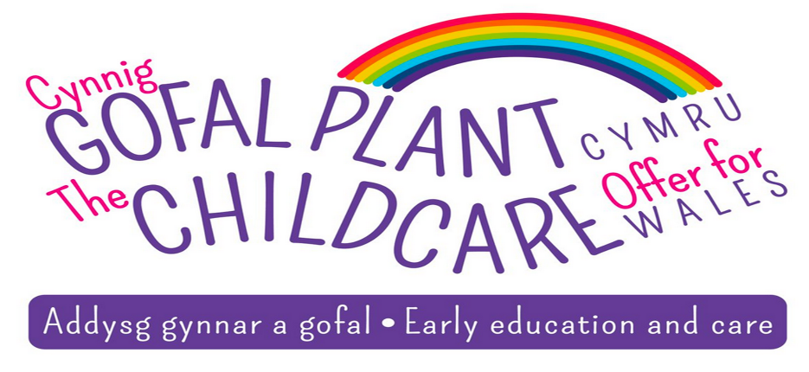
In addition to the 38 ‘term time’ weeks, there are also nine weeks of holiday entitlement to help with childcare costs during school holidays. For these weeks, up to 30 hours of childcare will be funded for eligible working parents.

As a farmer am I eligible for the Childcare Offer?
Farmers wishing to access the Childcare Offer must live in Wales and be earning at least the equivalent of 16 hours work at the national minimum or national living wage, per week.
We recognise the long hours farmers are working, however eligibility is not based on how many hours a parent is working, but on whether parents are either employed/self-employed and are able to evidence that they meet the minimum income test, i.e. they earn the equivalent of at least 16 hours per week of minimum wage at the rate applicable to them.
For example, farmers over the age of 23 would need to show that they earned at least £142.56 per week or £7,413.12 per annum, based on the national living wage rate of £8.91 per hour (rate as of April 2021).
Childcare providers in either Wales or England can be used to provide the government-funded childcare. If the provider is located in Wales they must be registered with Care Inspectorate Wales, or Ofsted if they are operating in England. Childcare provided by nannies or family members is not eligible for the funding under the Childcare Offer.

What is classed as income?
Any income generated through farming activity is classed as income.
In addition, subsidies and grants received by farmers, such as the Basic Payment Scheme, are generally recognised as receipts of their farming trade. As such where a parent can evidence that they have received a subsidy, this will count as income for the minimum income test.
The main exception to grants counting towards the minimum income test would be capital grants. Therefore a grant to buy a tractor or to rehabilitate flood damaged land for example, would not count as income for the minimum income test.

What evidence do you need to provide?
Many farmers run business accounts and do not take regular wages from the farm, which can make it difficult to evidence the income necessary to qualify for the Childcare Offer.
When assessing applications to see if they meet the minimum income test, your local authority can consider evidence of the average income from the last three months.
Typically, wage slips are used to show the income before any stoppages. This must show that parents meet the minimum income criteria.
The farm’s accounts are also acceptable, but these must show that wages meeting the criteria have been drawn or that the taxable profit of the farm would meet the minimum level of income required.
Any changes to income after an application has been submitted or while the Childcare Offer is being claimed must be notified to the local authority so eligibility can be reassessed.

How do I apply and where can I get more advice?
For information on how to apply for the Childcare Offer and more detailed advice about support for childcare that may be available to you, you should contact your local Family Information Service (FIS).
You can find contact details for the FIS in your local authority at http://www.fis.wales/