FlintMAP Instructions

*Setting up your laptop to allow remote working*

Version 17.0

Contents

Using a Flintshire County Council work laptop 3

Using your own personal laptop or PC 3

Installing Citrix Workspace on a personal laptop or PC 4

Signing into FlintMAP 6

Citrix StoreFront 8

Forgotten password 9

Technical Support 10

The Flintshire Mobile Access Portal is otherwise known as FlintMAP and will be referred to as such throughout this document.

# Using a Flintshire County Council work laptop

If you are using a Flintshire issued laptop this should already be set up for you to use FlintMAP. You can access it by using the icon on your desktop:

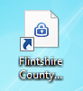

If this icon is present now proceed to the ‘Logging into the FlintMAP portal’ section. Otherwise, enter the web address shown below and add your own browser bookmark or desktop shortcut.

*You will need to have been assigned Remote Access privileges. If this hasn’t been done, you can request it via the “Remote Working” option in TOPdesk self service.*

# Using your own personal laptop or PC

*This also applies to laptops and PCs provided by other organisations.*



You should navigate to the FlintMAP address:

*FlintMAP web address:*

<https://flintmap.flintshire.gov.uk/>

Now follow the steps to install Citrix Workspace

# Installing Citrix Workspace on a personal laptop or PC

**This is not necessary on a Flintshire County Council work laptop as the software is pre-installed

To allow the use of the applications within FlintMAP on your personal laptop or PC, you will need to install the latest version of the Citrix Workspace software.

1. Click the ‘Citrix Workspace App Download’ link in the bottom corner of the FlintMAP sign in page:

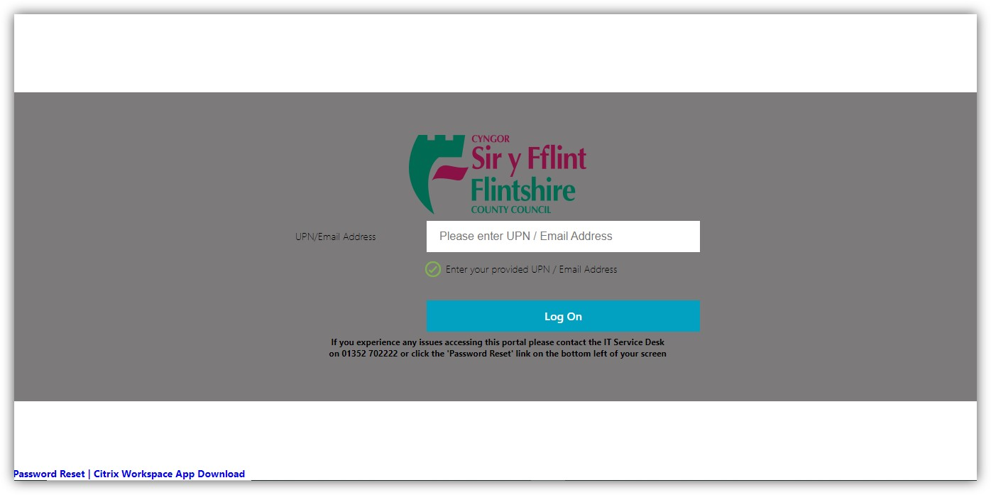

You will see a screen similar to that shown below: 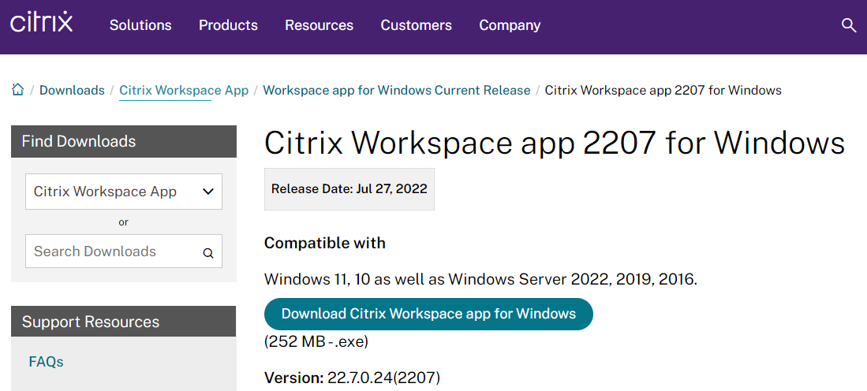

1. Click on “Download Citrix Workspace app for Windows”. This will prompt you to agree terms and conditions of the Citrix License Agreement click the box and press “Continue”.
2. Once downloaded, run the installation package
3. You may be asked if you want to let Citrix to make changes to your system. Click YES if prompted.
4. If you are already running a version of Citrix Workspace you may see a message similar to this:

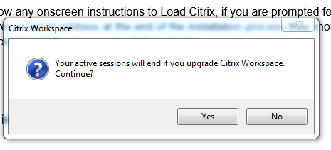

Click YES if prompted

1. Start the installation:

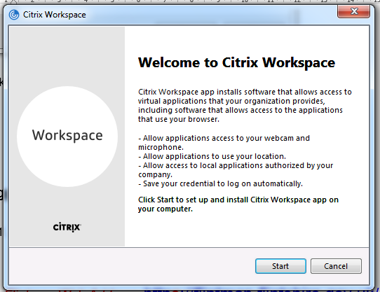

1. Click Finish once completed

# Signing into FlintMAP

**Before signing in to FlintMAP, ensure that you have set up Microsoft Authentication to use with your account. A separate guide is available: “[Multi Factor Authentication (MFA)”.](https://flintshire.topdesk.net/tas/public/ssp/content/detail/knowledgeitem?unid=e886aa5e-83ea-495e-8c1d-ba6cdc8cbe02)

1. If you are not already at the sign in page, enter the following address in your browser:

<https://flintmap.flintshire.gov.uk/>

1. You will now be directed to the Citrix Access Gateway page below:



1. Enter your email address and click “Log On”
2. Enter your password when prompted. On a Flintshire laptop, this is the same password that you use to sign into Microsoft Windows.

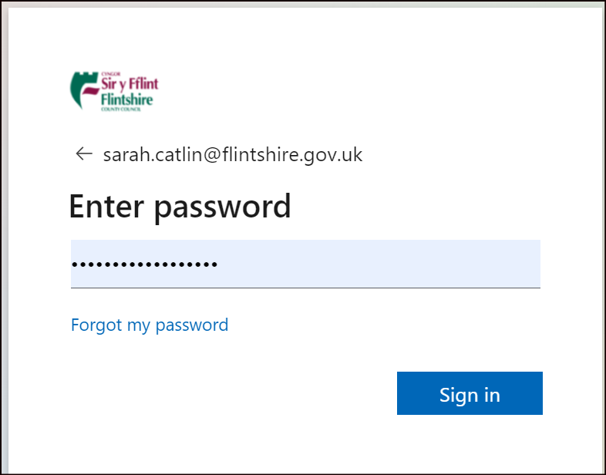

1. Follow the on-screen instructions to complete sign on using Microsoft Authentication. The instructions will vary, depending on the additional security verification method you have chosen to use.

## Citrix StoreFront

Once you havesuccessfully signed in, you will see options for Home and Apps:

The most common apps will automatically appear on the Home screen. Click on an app group, such as “Office”, then click on the app that you want to open.ce

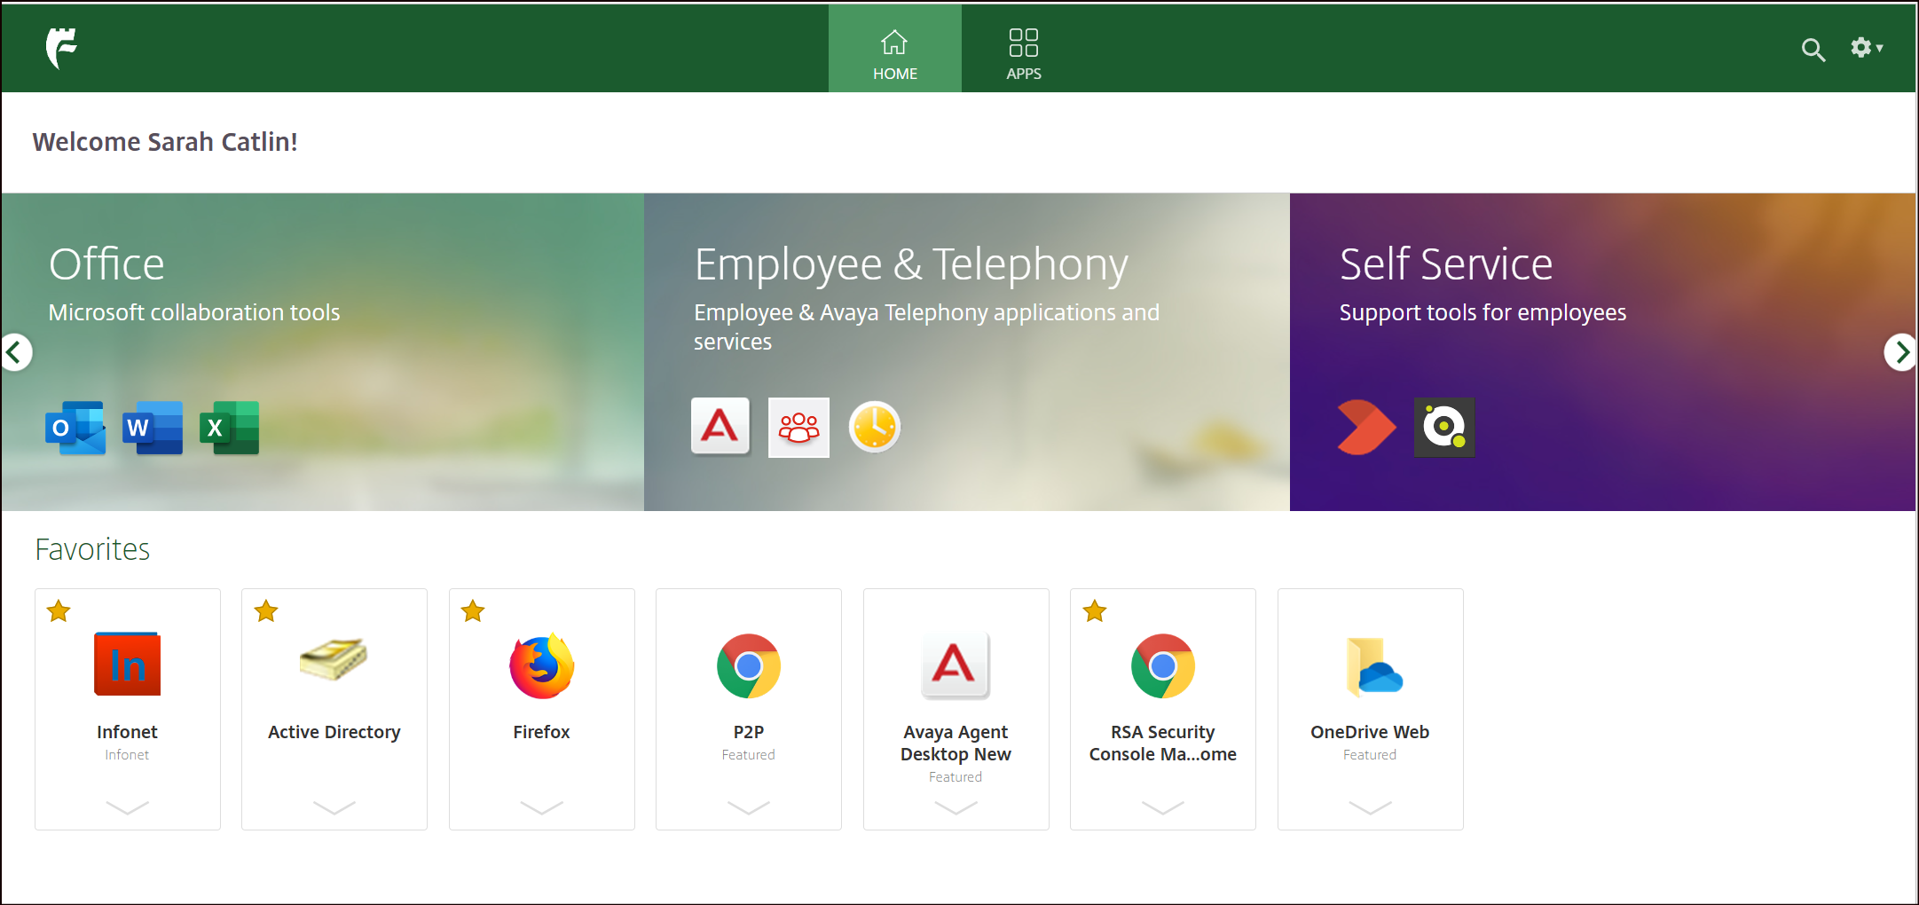

*Your browser may try to download an ‘ICA’ file when clicking an app. You should be prompted whether it should automatically be opened, and you should confirm this to avoid seeing this step in future.*

*If your browser has downloaded an ‘ICA’ file you can still run the app. Go to your Downloads folder, right click on the file and press ‘Always Open Files of this Type’*



The following will appear to illustrate progress with launching the app:

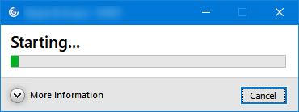

*The StoreFront portal will timeout if inactive for several hours. This will not affect applications that are already running but you will need to log back in to load additional ones.*

The ‘Apps’ screen will contain all the apps you have access to. You can star the ones that you would like to appear on the Home screen

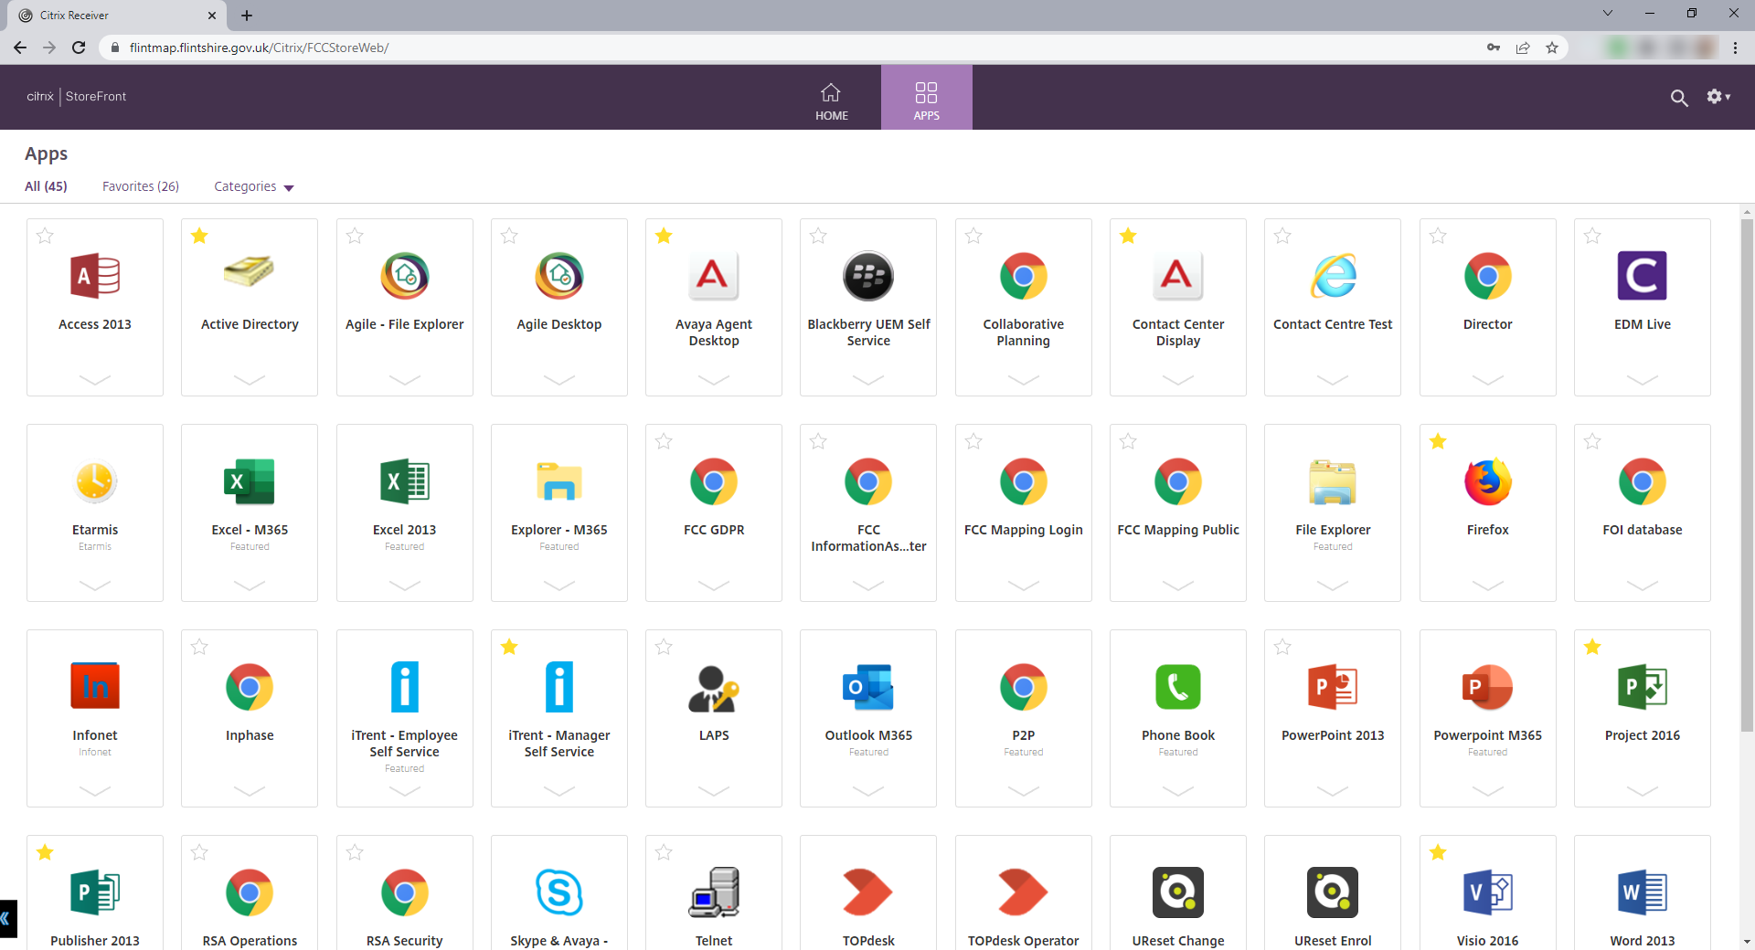

# Forgotten password

If you forget your password or might have locked your main account through incorrect passwords being entered at the sign-in stage, you can rectify this yourself using the ‘Password Reset’ option. This will subsequently give the options of reset (forgotten password), change (current password is known) or unlock.

There is a separate guide for using this option to [unlock your password](https://flintshire.topdesk.net/tas/public/ssp/content/detail/knowledgeitem?unid=0bcdefad-5258-44dc-bcb7-aa602d5ab4e6).



# Technical Support

If you experience any technical difficulties when trying to access FlintMAP please contact the IT Service Desk on 01352 70(2222), the service is open 08:00-17:00 Monday to Thursday and 08:00-16:30 on a Friday.