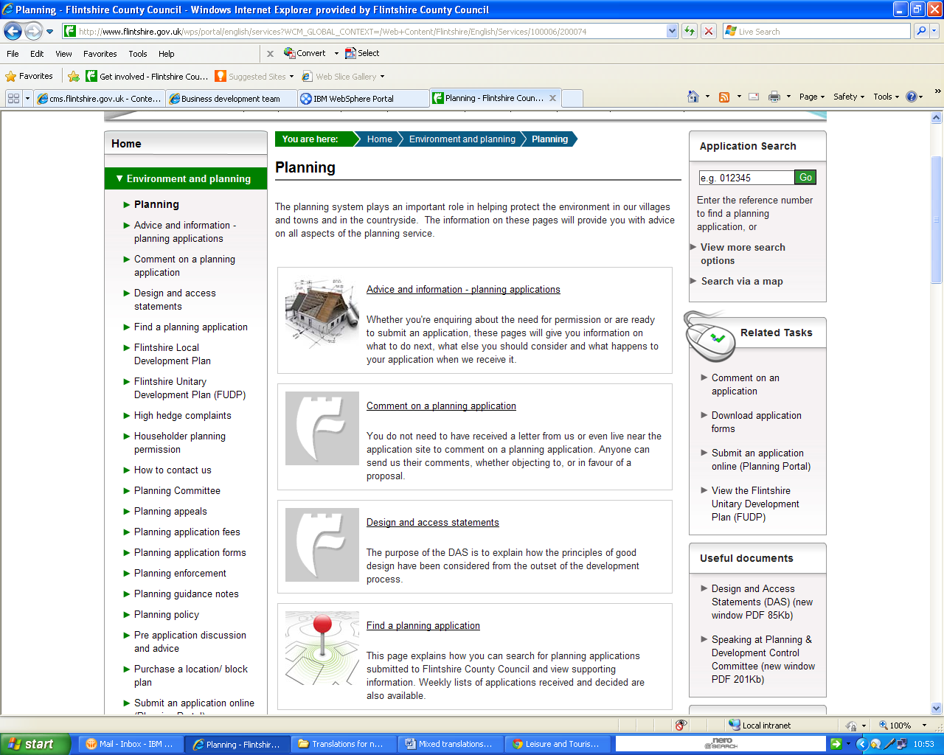
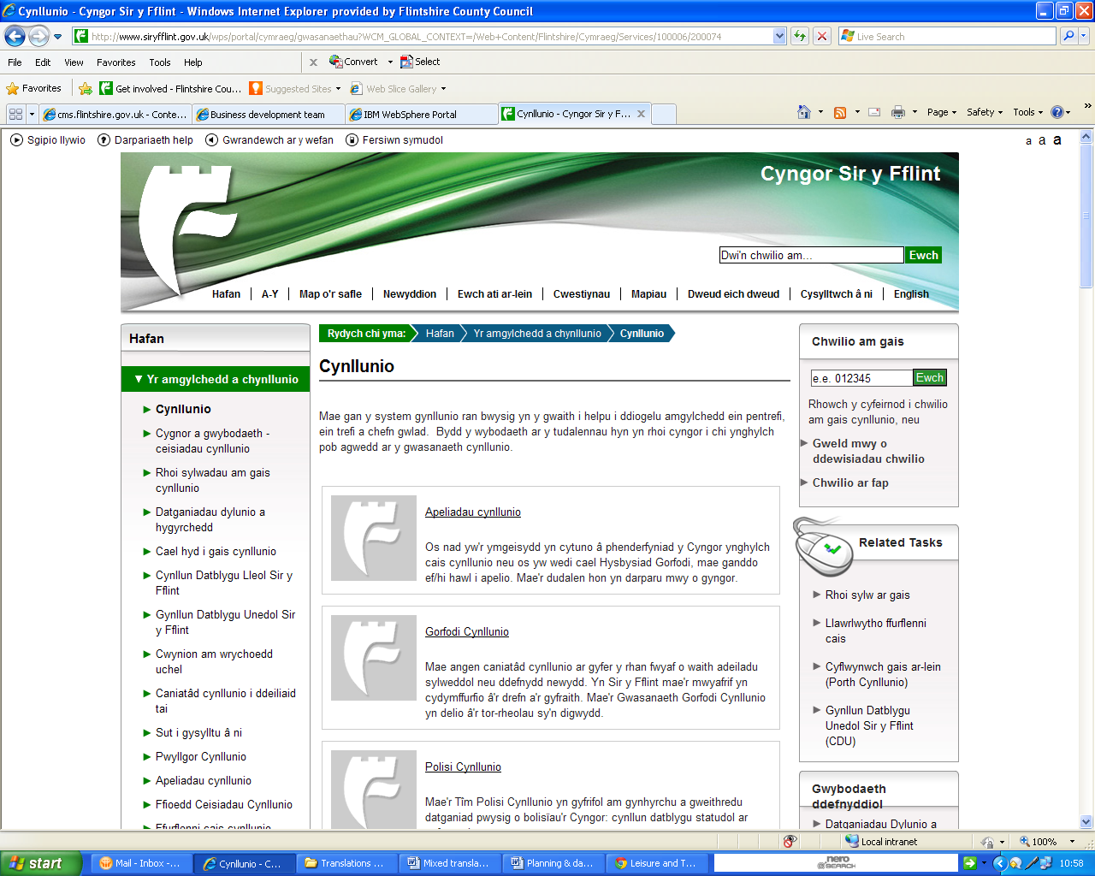
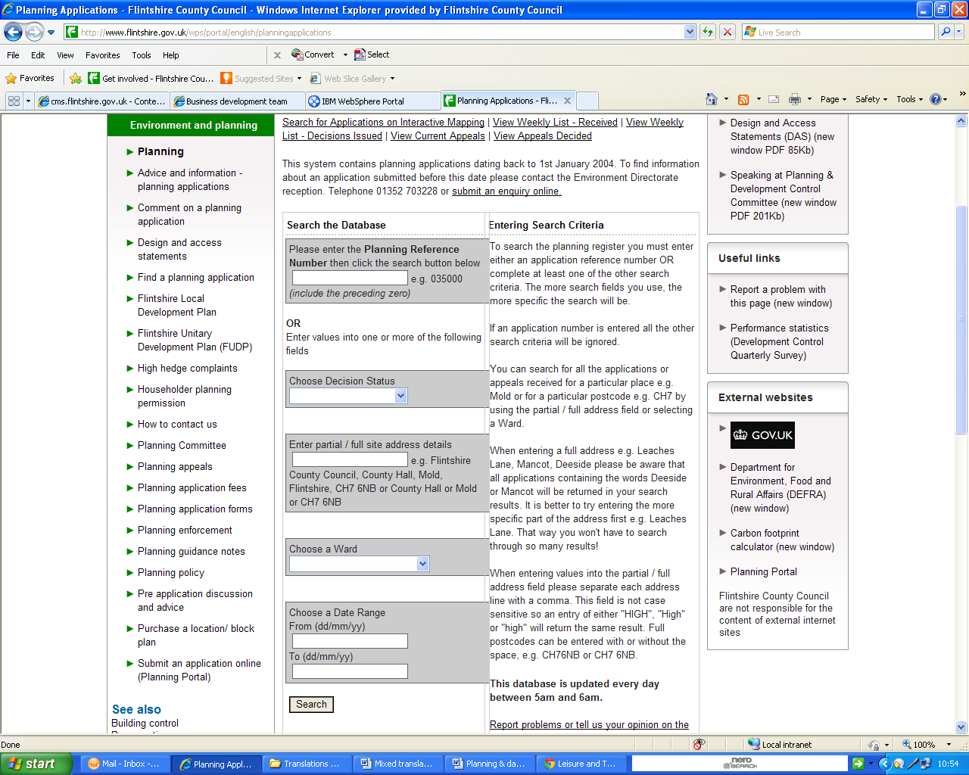

Planning Applications Search

Search for Applications on Interactive Mapping | View Weekly List - Received | View Weekly List - Decisions Issued | View Current Appeals | View Appeals Decided
This system contains planning applications dating back to 1st January 2004. To find information about an application submitted before this date please contact the Environment Directorate reception. Telephone 01352 703228 or submit an enquiry online.
Top of Form
Search the Database  OR  Enter values into one or more of the following fields | Entering Search Criteria  To search the planning register you must enter either an application reference number OR complete at least one of the other search criteria. The more search fields you use, the more specific the search will be.  If an application number is entered all the other search criteria will be ignored.  You can search for all the applications or appeals received for a particular place e.g. Mold or for a particular postcode e.g. CH7 by using the partial / full address field or selecting a Ward.  When entering a full address e.g. Leaches Lane, Mancot, Deeside please be aware that all applications containing the words Deeside or Mancot will be returned in your search results. It is better to try entering the more specific part of the address first e.g. Leaches Lane. That way you won't have to search through so many results!  When entering values into the partial / full address field please separate each address line with a comma. This field is not case sensitive so an entry of either "HIGH", "High" or "high" will return the same result. Full postcodes can be entered with or without the space, e.g. CH76NB or CH7 6NB.  This database is updated every day between 5am and 6am.  Report problems or tell us your opinion on the Planning Applications Database
  Please enter the Planning Reference Number then click the search button below
  e.g. 035000 (include the preceding zero)
  Choose Decision Status
  Enter partial / full site address details
  e.g. Flintshire County Council, County Hall, Mold, Flintshire, CH7 6NB or County Hall or Mold or CH7 6NB
  Choose a Ward
  Choose a Date Range
  From (dd/mm/yy)
  To (dd/mm/yy)
Bottom of Form

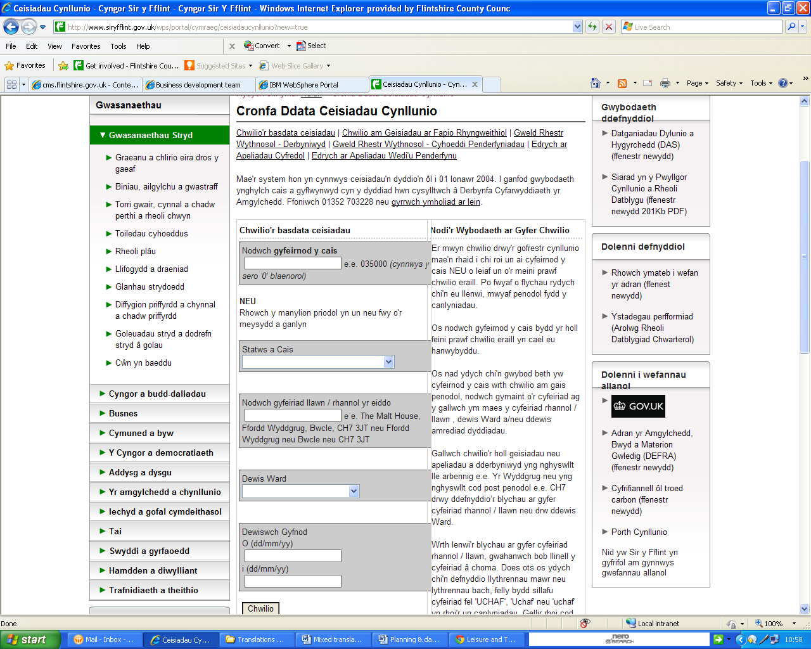

Cronfa Ddata Ceisiadau Cynllunio

Chwilio'r basdata ceisiadau | Chwilio am Geisiadau ar Fapio Rhyngweithiol | Gweld Rhestr Wythnosol - Derbyniwyd | Gweld Rhestr Wythnosol - Cyhoeddi Penderfyniadau | Edrych ar Apeliadau Cyfredol | Edrych ar Apeliadau Wedi'u Penderfynu
Mae'r system hon yn cynnwys ceisiadau'n dyddio'n ôl i 01 Ionawr 2004. I ganfod gwybodaeth ynghylch cais a gyflwynwyd cyn y dyddiad hwn cysylltwch â Derbynfa Cyfarwyddiaeth yr Amgylchedd. Ffoniwch 01352 703228 neu gyrrwch ymholiad ar lein.
Top of Form
Chwilio'r basdata ceisiadau  NEU  Rhowch y manylion priodol yn un neu fwy o'r meysydd a ganlyn | Nodi'r Wybodaeth ar Gyfer Chwilio  Er mwyn chwilio drwy'r gofrestr cynllunio mae'n rhaid i chi roi un ai cyfeirnod y cais NEU o leiaf un o'r meini prawf chwilio eraill. Po fwyaf o flychau rydych chi'n eu llenwi, mwyaf penodol fydd y canlyniadau.  Os nodwch gyfeirnod y cais bydd yr holl feini prawf chwilio eraill yn cael eu hanwybyddu.  Os nad ydych chi'n gwybod beth yw cyfeirnod y cais wrth chwilio am gais penodol, nodwch gymaint o'r cyfeiriad ag y gallwch ym maes y cyfeiriad rhannol / llawn , dewis Ward a/neu ddewis amrediad dyddiadau.  Gallwch chwilio'r holl geisiadau neu apeliadau a dderbyniwyd yng nghyswllt lle arbennig e.e. Yr Wyddgrug neu yng nghyswllt cod post penodol e.e. CH7 drwy ddefnyddio’r blychau ar gyfer cyfeiriad rhannol / llawn neu drw ddewis Ward.  Wrth lenwi'r blychau ar gyfer cyfeiriad rhannol / llawn, gwahanwch bob llinell y cyfeiriad â choma. Does ots os ydych chi'n defnyddio llythrennau mawr neu lythrennau bach, felly bydd sillafu cyfeiriad fel 'UCHAF', 'Uchaf' neu 'uchaf' yn rhoi'r un canlyniadau. Gellir rhoi cod post llawn gyda'r bwlch yn y canol neu hebddo e.e. CH76NF neu CH7 6NF.  Caiff y gronfa ddata ei ddiweddaru bob dydd rhwng 5am - 6 am.  Adrodd yn ôl ar broblemau neu roi eich barn i ni ar y Basdata Ceisiadau Cynllunio
  Nodwch gyfeirnod y cais
  e.e. 035000 (cynnwys y sero '0' blaenorol)
  Statws a Cais
  Nodwch gyfeiriad llawn / rhannol yr eiddo
  e e. The Malt House, Ffordd Wyddgrug, Bwcle, CH7 3JT neu Ffordd Wyddgrug neu Bwcle neu CH7 3JT
  Dewis Ward
  Dewiswch Gyfnod
  O (dd/mm/yy)
  i (dd/mm/yy)
Bottom of Form

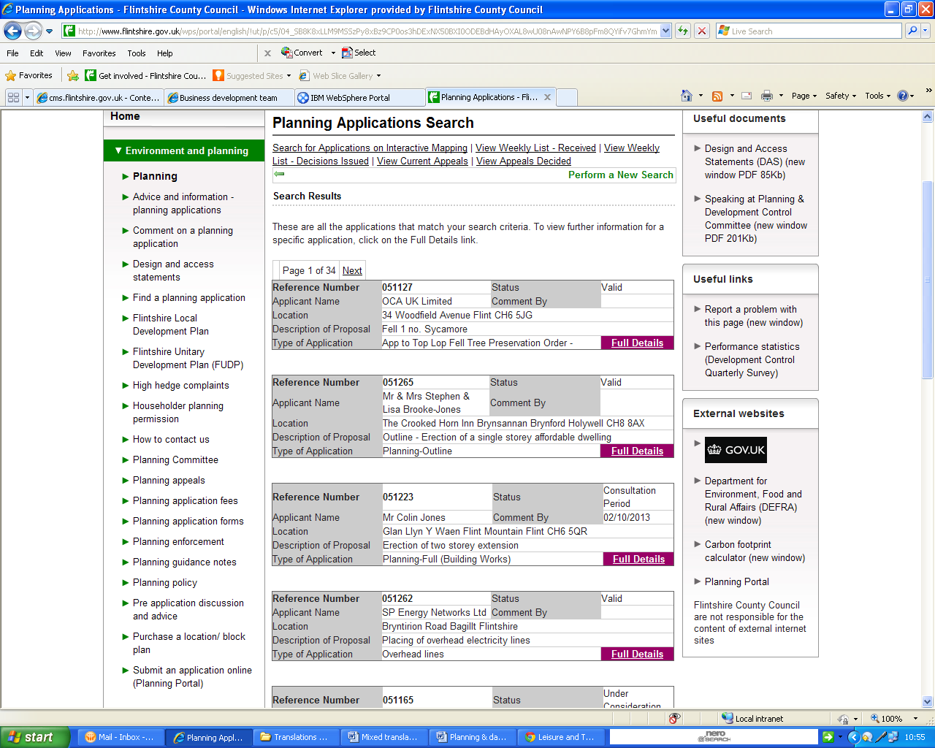
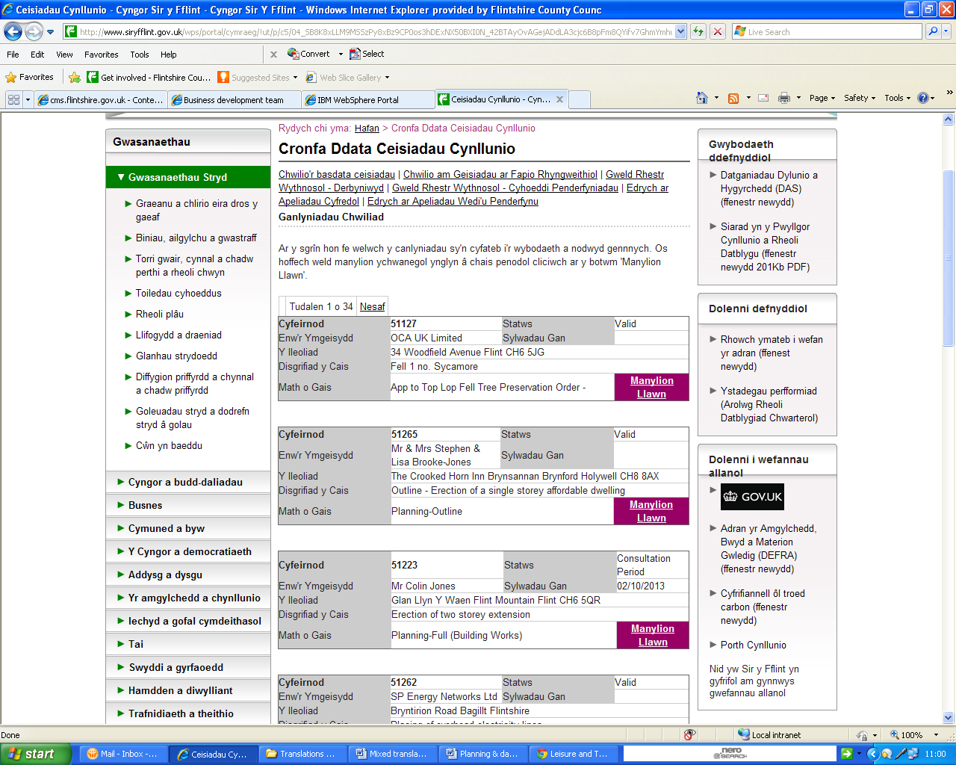
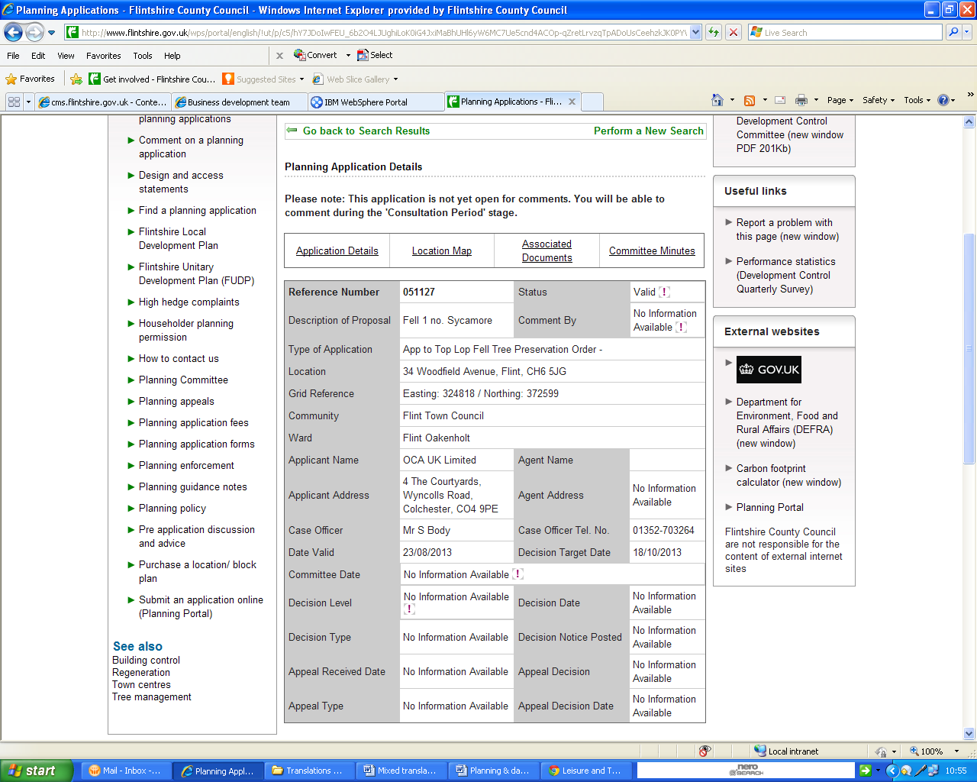
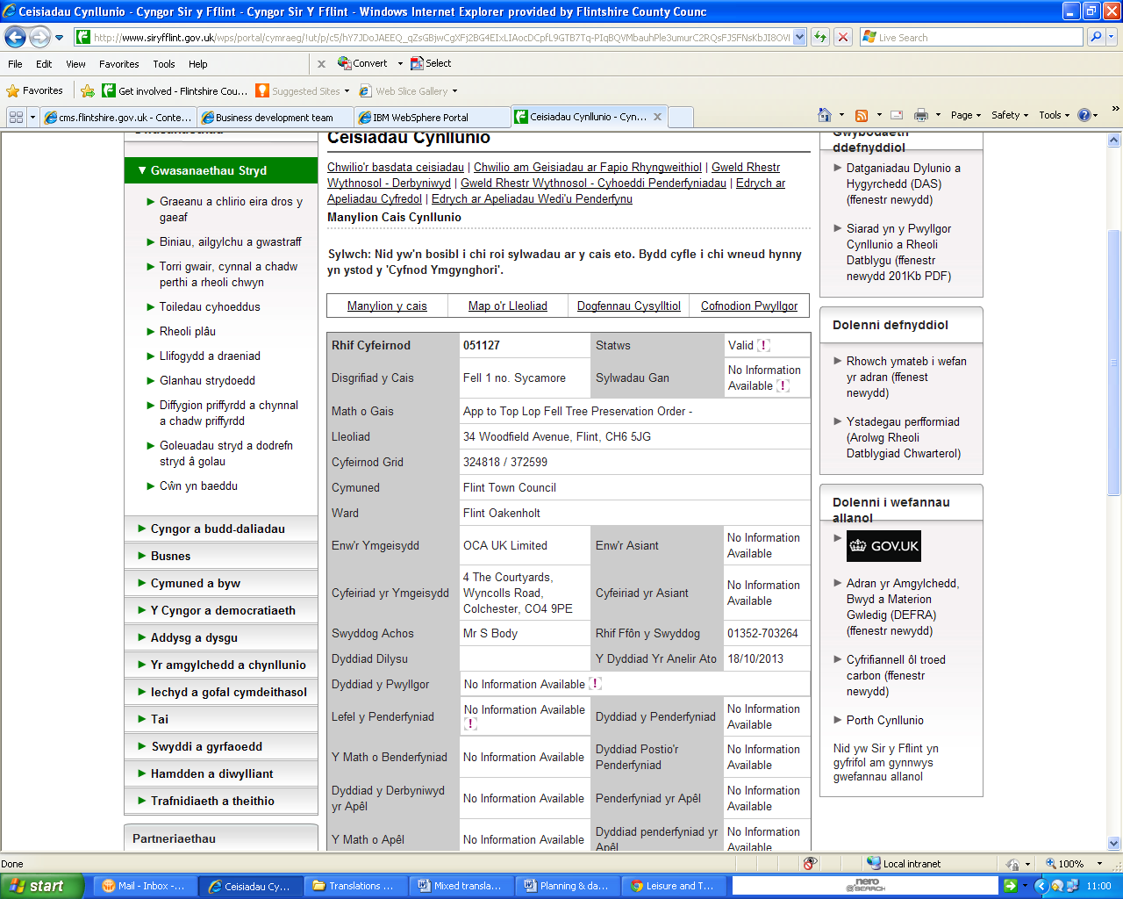
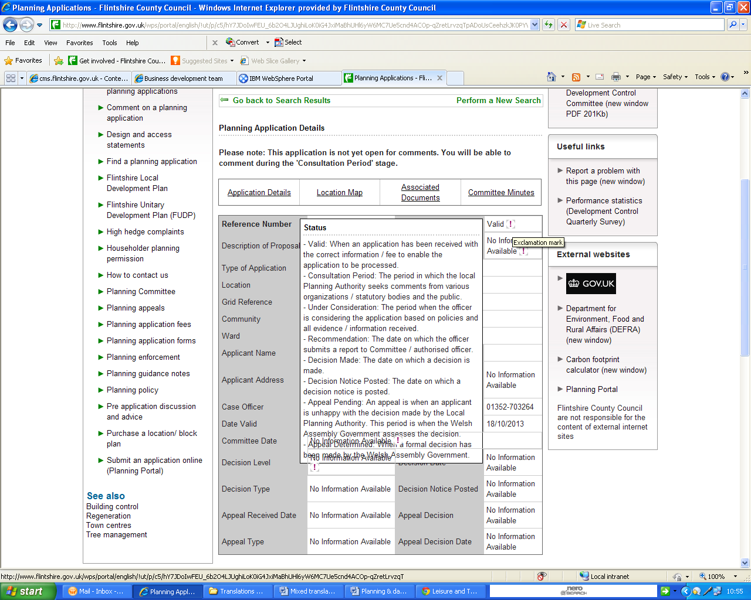
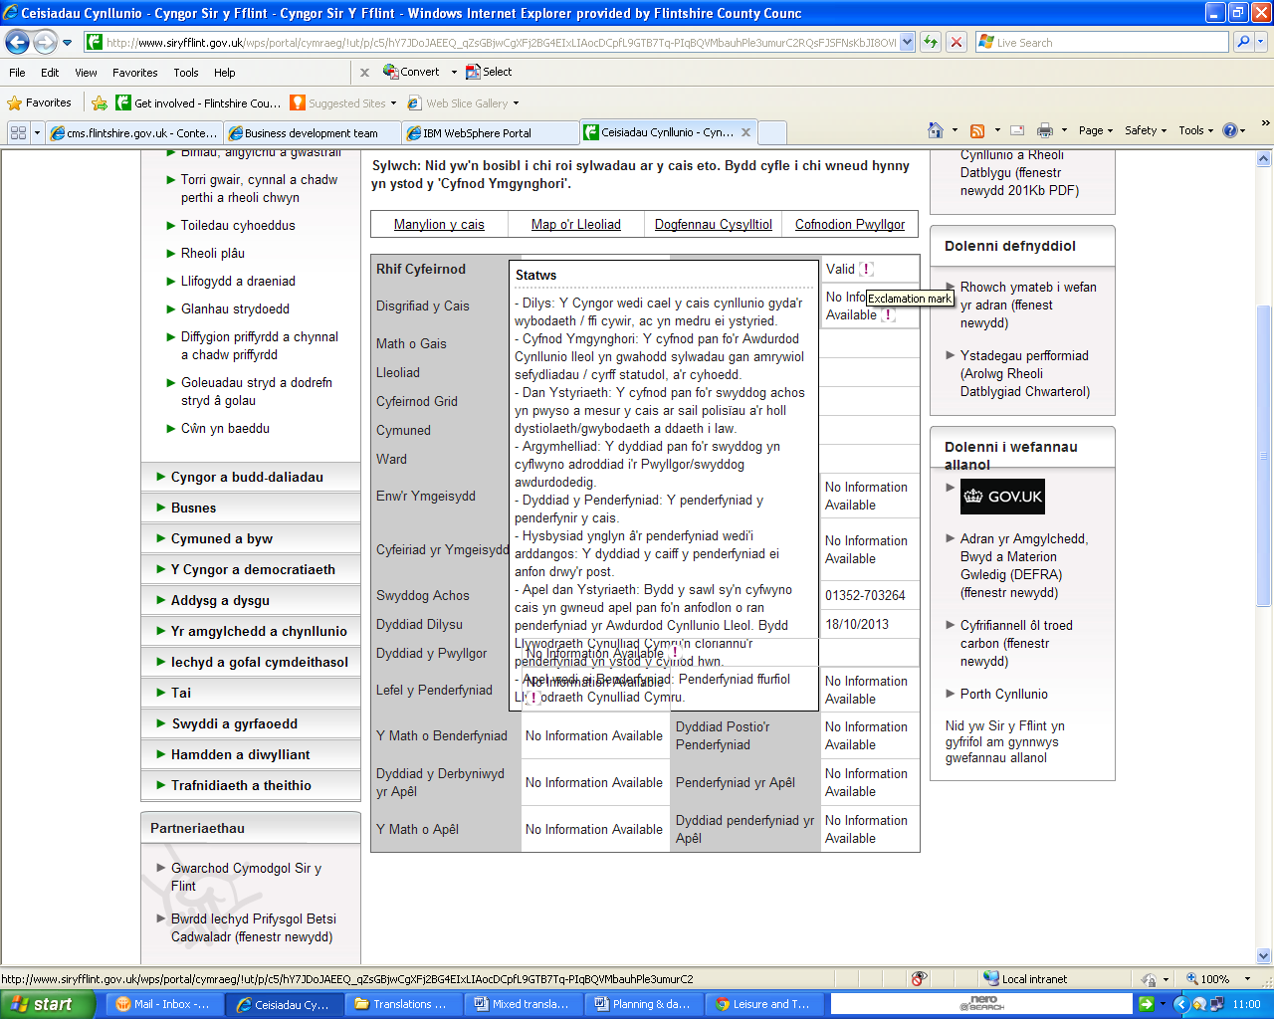
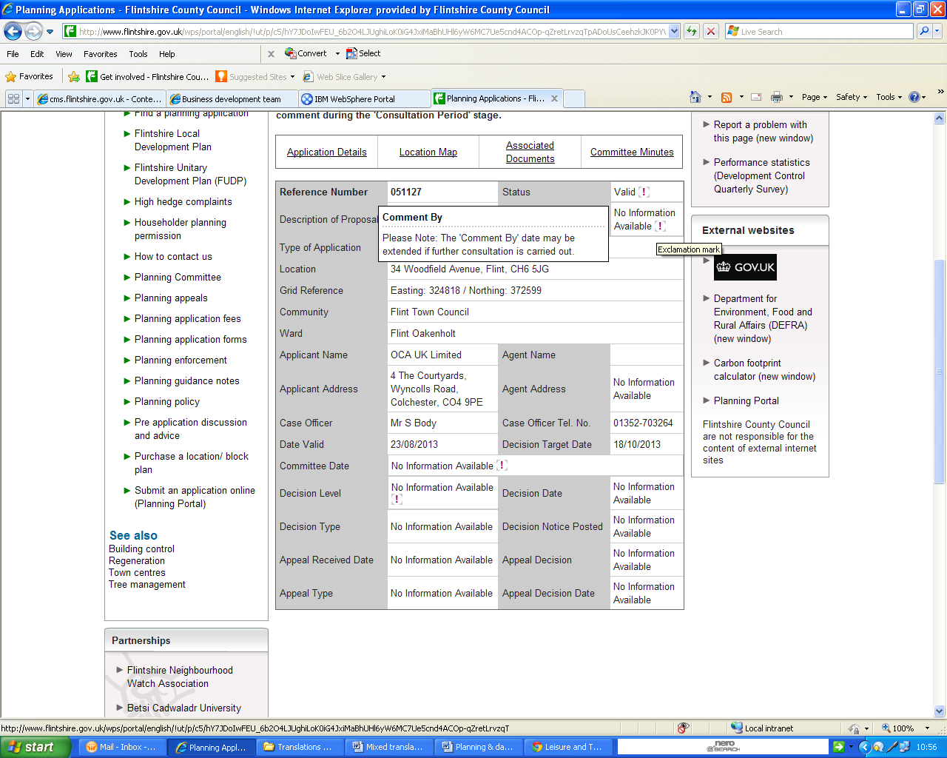
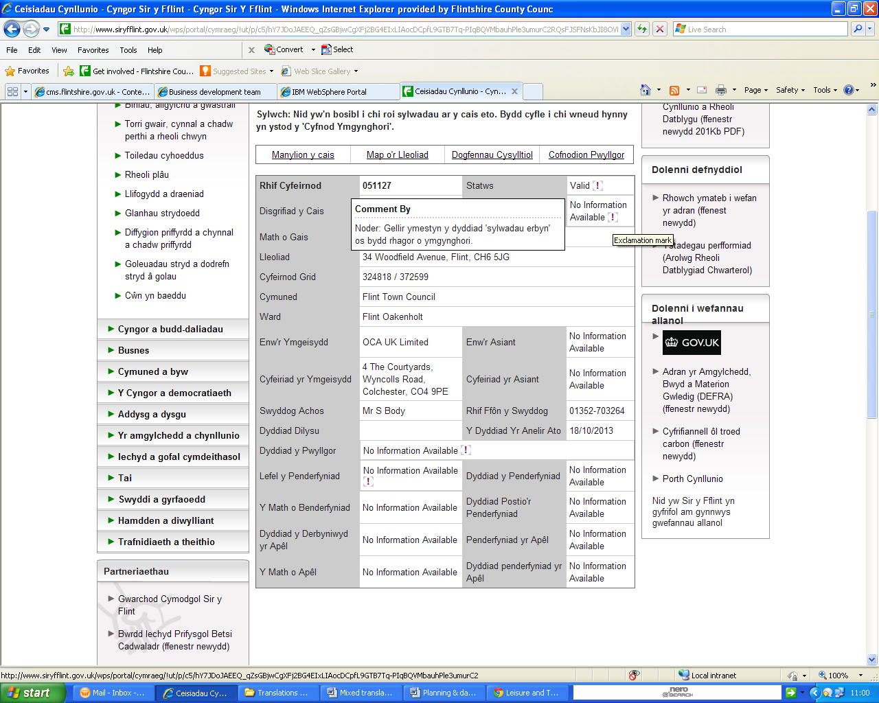
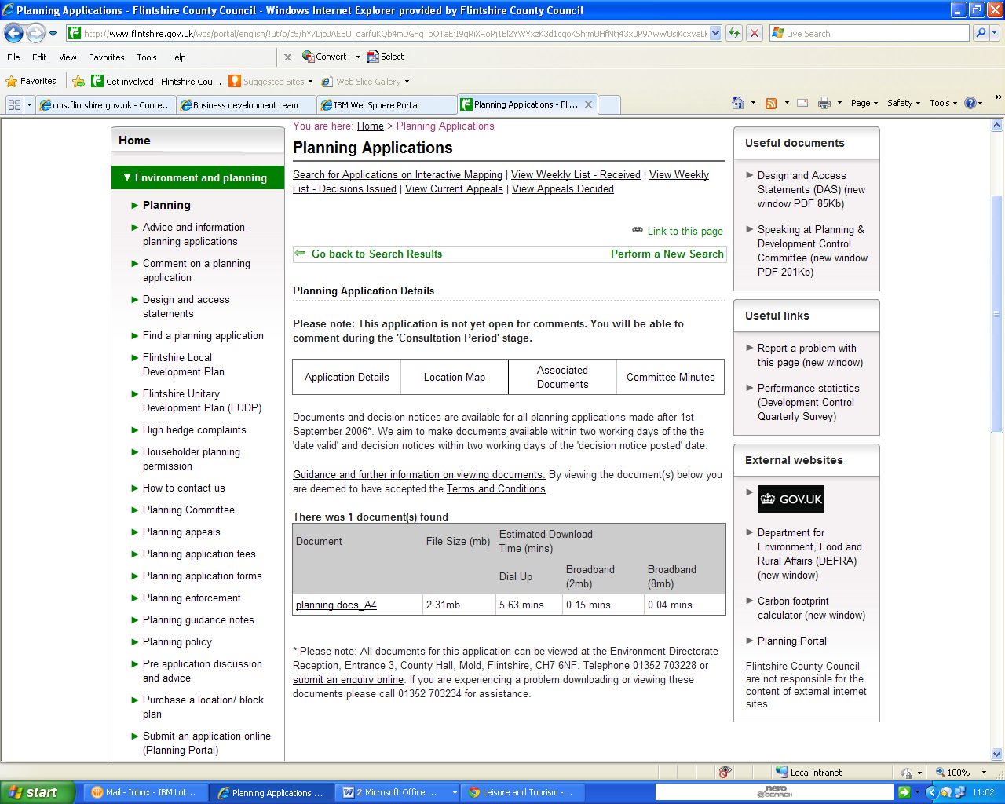
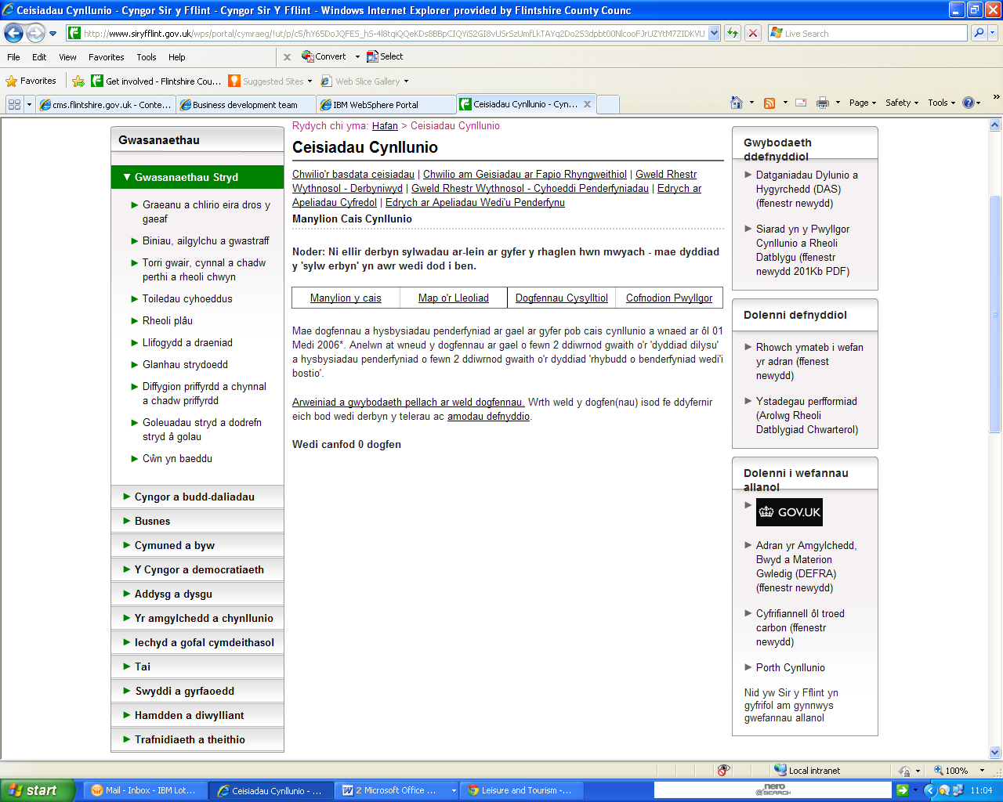
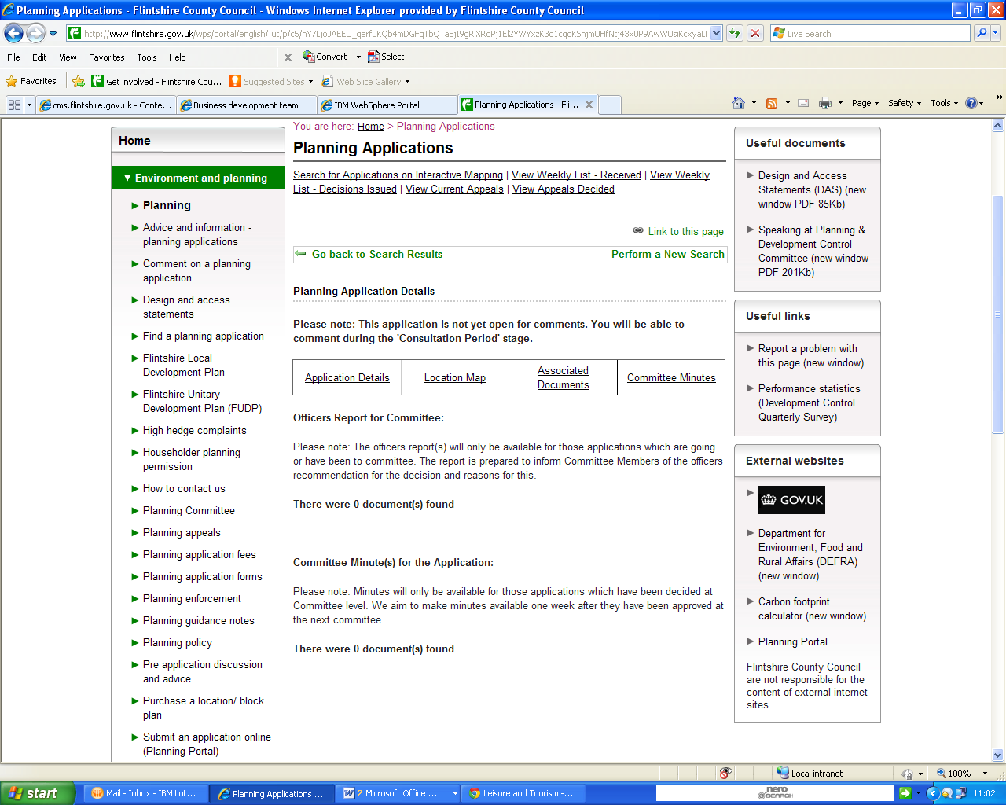
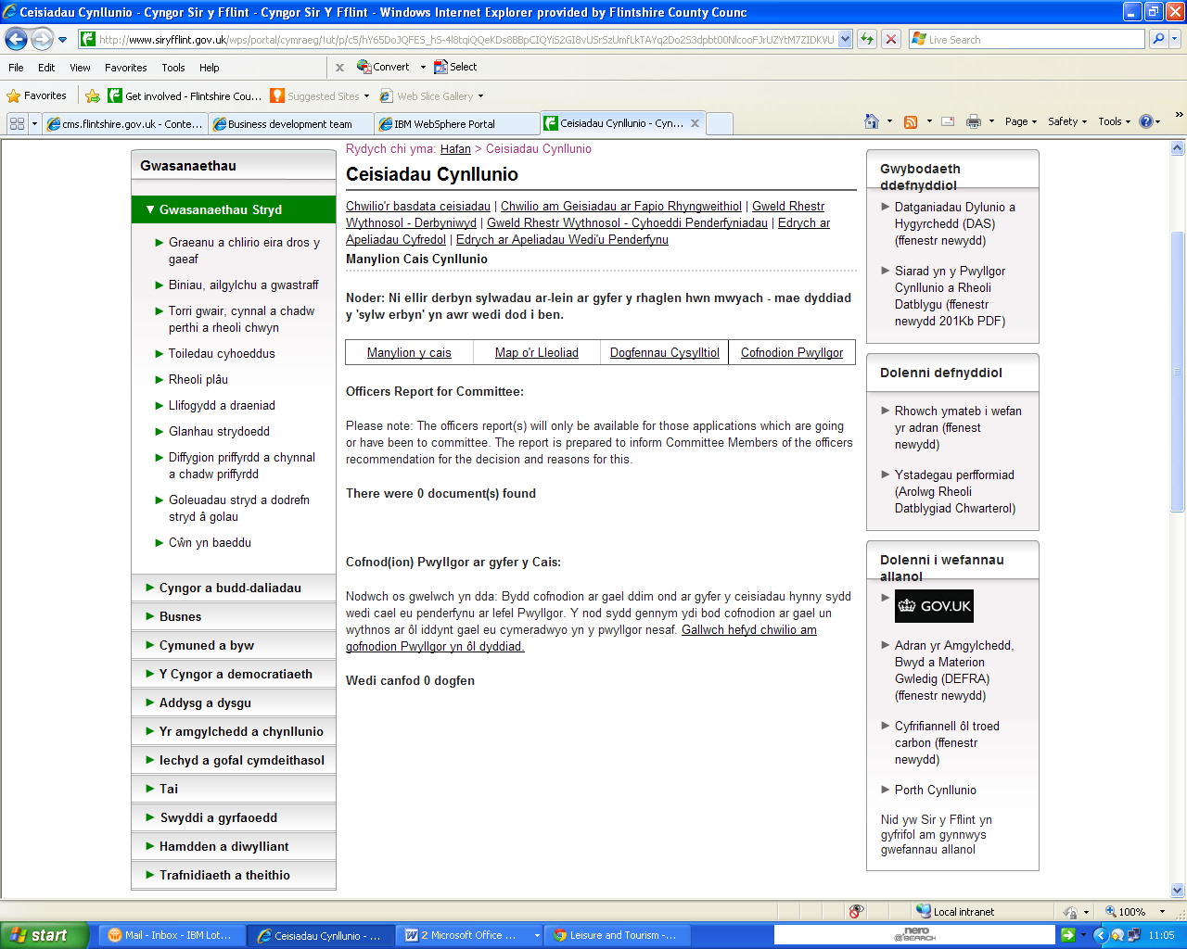
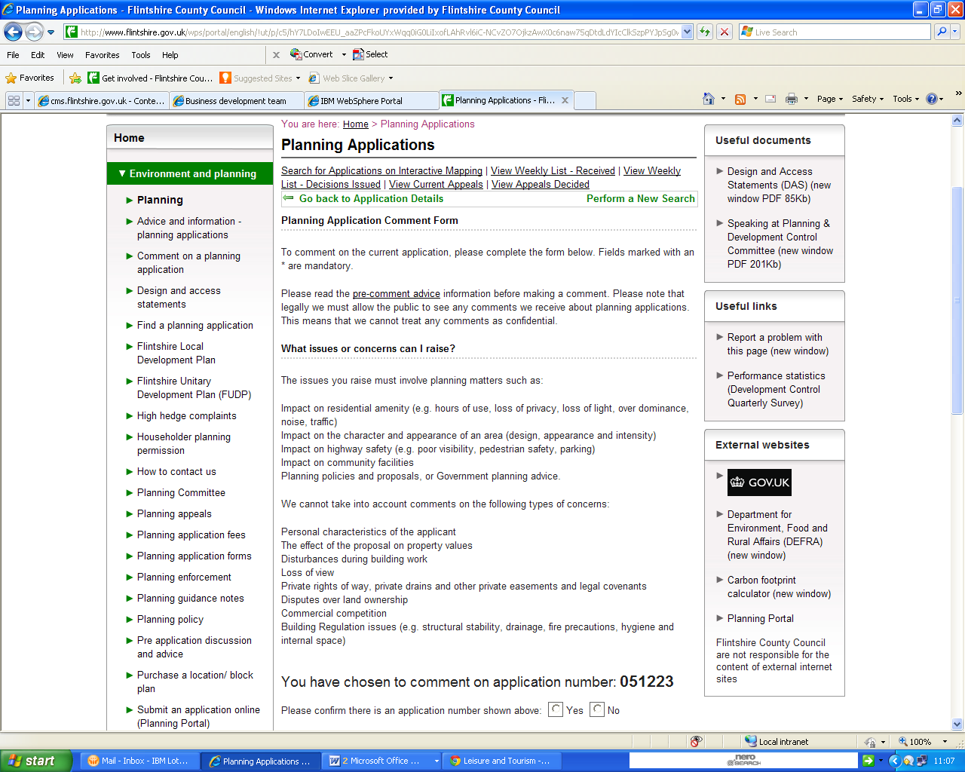
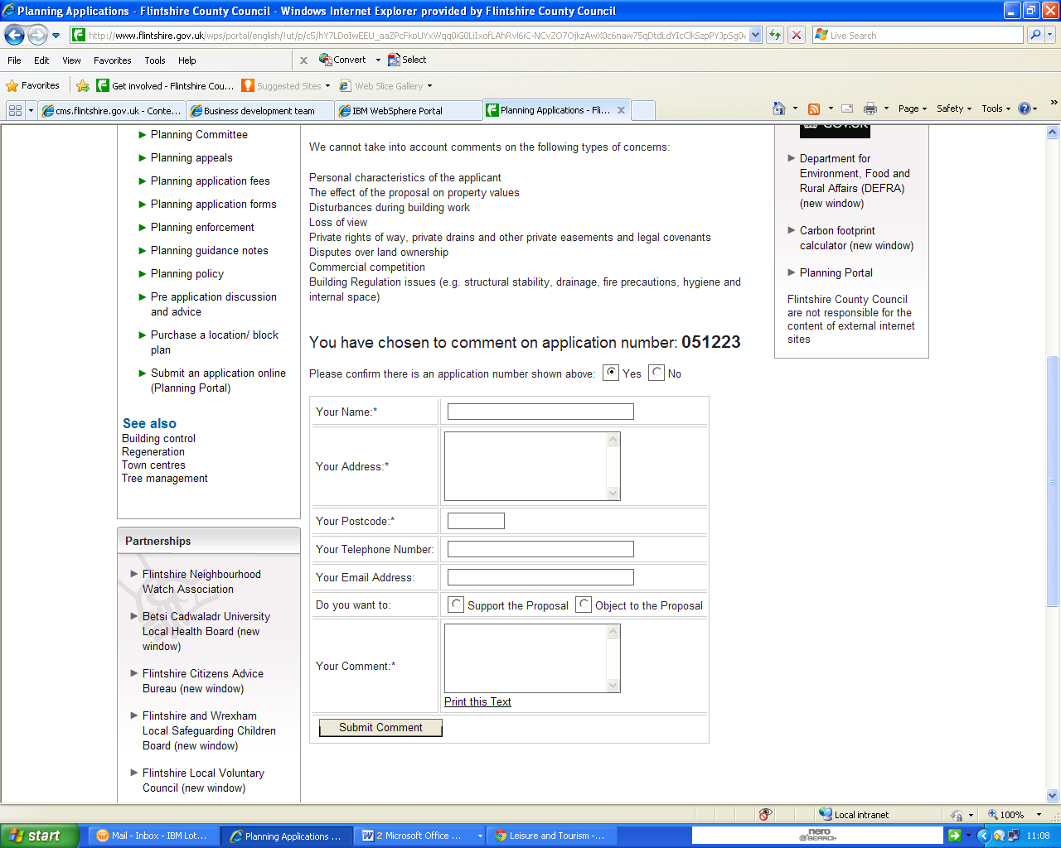

Planning Application Comment Form
To comment on the current application, please complete the form below. Fields marked with an * are mandatory.
Please read the pre-comment advice information before making a comment. Please note that legally we must allow the public to see any comments we receive about planning applications. This means that we cannot treat any comments as confidential.

What issues or concerns can I raise?
The issues you raise must involve planning matters such as:
- Impact on residential amenity (e.g. hours of use, loss of privacy, loss of light, over dominance, noise, traffic)
- Impact on the character and appearance of an area (design, appearance and intensity)
- Impact on highway safety (e.g. poor visibility, pedestrian safety, parking)
- Impact on community facilities
- Planning policies and proposals, or Government planning advice.
We cannot take into account comments on the following types of concerns:
- Personal characteristics of the applicant
- The effect of the proposal on property values
- Disturbances during building work
- Loss of view
- Private rights of way, private drains and other private easements and legal covenants
- Disputes over land ownership
- Commercial competition
- Building Regulation issues (e.g. structural stability, drainage, fire precautions, hygiene and internal space)

Top of Form
You have chosen to comment on application number: 051223
Please confirm there is an application number shown above: Yes No

Your Name:*
Your Address:*
Your Postcode:*
Your Telephone Number:
Your Email Address:
Do you want to: | Support the Proposal Object to the Proposal
Your Comment:* | Print this Text
Bottom of Form

Useful documents
Design and Access Statements (DAS) (new window PDF 85Kb)Speaking at Planning & Development Control Committee (new window PDF 201Kb)

Useful links
Report a problem with this page (new window)Performance statistics (Development Control Quarterly Survey)

External websites
Department for Environment, Food and Rural Affairs (DEFRA) (new window) Carbon footprint calculator (new window)Planning Portal
Flintshire County Council are not responsible for the content of external internet sites

