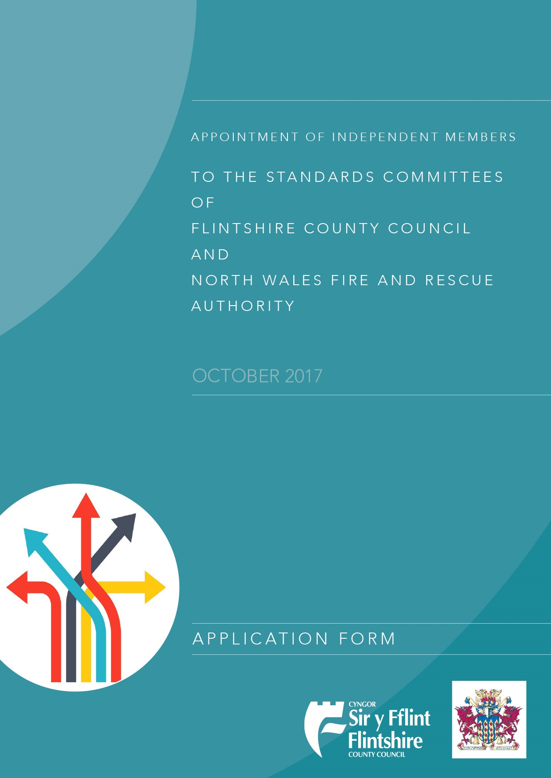

Please indicate below which Committee(s) you are applying for:

Flintshire County Council |  |  | North Wales Fire and Rescue Authority |  |  | Both

Title (Mr/Mrs/Miss/Ms)
Surname
Forename(s)
Contact information
Home address
Phone number
Email

- Please provide details of your present occupation and employer and any work related professional or academic qualifications.

- Have you ever worked for North Wales Fire and Rescue Authority and/or Flintshire County Council or any other local authority including a town, community or parish council?

YES NO

If YES, please give details including dates

- Is your spouse or partner employed by any local authority?

YES NO

If YES, please give details

- Are you or your spouse or partner, or have either of you ever been, a serving member of any local authority?

YES N NO

If YES, please provide the name of the Authority and relevant dates

- Are you a member of any political party or active in local politics?

YES NO

If YES, please give details

- Have you had any significant dealings with North Wales Fire and Rescue Authority and/or Flintshire County Council since they were formed?

YES NO

If YES, please give details

- Have you been involved in any criminal proceedings?

YES NO

If YES, please give details

- Is there anything in your private or working life or in your past or to your knowledge in that any member of your family or close friends which, if it became generally known might bring you into disrepute or call into question your integrity, authority or standing in the community?

YES NO

If YES, please give details

- Please indicate why you are interested in serving as an independent member on the Standards Committee of North Wales Fire and Rescue Authority and/or Flintshire County Council. Include details of any previous experience or personal attributes which you believe make you particularly suitable for this role.

Signed: …………………………………………………….. Date: …………………………

Complete and send this form via email to :

gareth.legal@flintshire.gov.uk

or post to:

Gareth Owens
Flintshire County Council
County Hall
Mold CH7 6NB

*You must present 2 letters of reference with your application

Equality Monitoring Form
Gender and Gender Identity
What is your gender? |  |  |  |  | Female
 |  |  |  |  | Male
At birth were you described as? |  |  |  |  | Female
 |  |  |  |  | Male
 |  |  |  |  | Intersex
 |  |  |  |  | Prefer not to say
Disability
Are your day-to-day activities limited because of a physical or mental health condition, illness or disability which has lasted, or is expected to last 12 months or more? |  |  |  |  | Yes – limited a lot
 |  |  |  |  | Yes – limited a little
 |  |  |  |  | No
 |  |  |  |  | Prefer not to say
Age
What is your date of birth?:
National Identity
National Identity – how would you describe your national identity?
Welsh | English |  |  |  | Scottish |  | Northern Irish |  | British
Other (please specify) |  |  |  |  |  | Prefer not to say
Ethnic Group
Ethnicity – how would you describe your ethnic group?
White
Welsh/English/Scottish/Northern Irish/British |  |  |  |  |  | Irish
Gypsy or Irish Traveller |  |  |  | Any other white background (please specify):
Mixed/multiple ethnic groups
White and Black Caribbean |  |  | White and Black African |  |  |  |  | White and Asian
Any other Mixed/multiple ethnic background (please specify):
Asian/Asian British
Indian | Pakistani |  |  |  | Bangladeshi |  | Chinese
Any other Asian background (please specify):
Black/African/Caribbean/Black British
African |  | Caribbean
Any other Black/African/Caribbean background (please specify):
Other ethnic group
Arab
Any other ethnic group (please specify):
Prefer not to say

 | Welsh Language
 | Please describe your Welsh language ability by ticking the relevant box(es) below.
 |  |  | Understand |  |  | Speak |  |  | Read |  |  | Write
 | None
 | Basic
 | Competent
 | Good
 | Fluent
Sexual Identity
Which of the following options best describes how you think of yourself?
Heterosexual/straight |  |  |  |  | Gay or lesbian |  |  |  |  | Bisexual
Other |  |  |  |  | Prefer not to say
Religion
What is your religion?
No religion |  | Christian (all denominations) |  |  |  |  |  | Buddhist
Hindu |  | Jewish |  |  | Muslim |  |  |  |  |  | Sikh
Any other religion (please specify): |  |  |  |  | Prefer not to say
Pregnancy and Maternity
Are you currently pregnant or have you been pregnant within the last year? |  |  |  |  |  |  | Yes
 |  |  |  |  |  |  | No
 |  |  |  |  |  |  | Prefer not to say
Have you taken maternity leave within the past year? |  |  |  |  |  |  | Yes
 |  |  |  |  |  |  | No
 |  |  |  |  |  |  | Prefer not to say
Marriage and Civil Partnership
What is your legal marital or same sex civil partnership status? |  |  |  | Single, that is never married and never registered in a same sex civil partnership
 |  |  |  | Married and living with husband/wife
 |  |  |  | Separated but still legally married
 |  |  |  | Divorced
 |  |  |  | Widowed
 |  |  |  | In a registered same-sex civil partnership and living with your partner
 |  |  |  | Separated, but still legally in a same-sex civil partnership
 |  |  |  | Formerly in a same-sex civil partnership which is now legally dissolved
 |  |  |  | Surviving partner from a same-sex civil partnership
 |  |  |  | Prefer not to say

